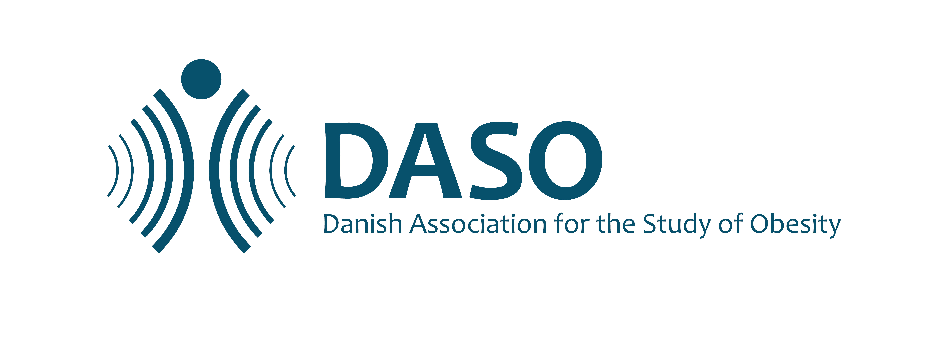

**Guidelines for abstract submission**

**DASO annual Obesity Meeting**

**November 1st-2nd 2024**

Please submit your abstract as a word file to [dsaf@dsaf.dk](mailto:dsaf@dsaf.dk) no later than **September 8th 2024**. The organizing committee will select abstracts for oral or poster presentations.

Awards for the oral presentations will be given to two early career researchers (PhD age < 10 years) to recognize excellence in their projects as well as the oral presentation. The winner receives 5000 Dkr and the runner up receives 2500 Dkr. Please note that award winners are expected to attend the award ceremony Friday evening).

All abstracts and suggestions must adhere to the EASO [person first language](https://cdn.easo.org/wp-content/uploads/2018/12/16195533/EASO-People-first-Language_Version-5-CMYK-for-print.pdf) guidelines. It is allowed to present data which previously has been presented or published.

Be sure your abstract contains the following information and adheres to the following formatting guidelines before submission:

**Abstract text:** The abstract main text must contain no more than 300 words with arial 10 PT. It must be written in English, in complete sentences, and include a title, author list and affiliations (presenting author underlined) and the following headings: background and aim, material and methods, results, and conclusions. The submitted file must be labelled with the name of the presenting author. No images, figures, charts or tables should be included in the abstract.

**Abstract template:**

**Title (Use a short and specific title) [arial 10 PT, bold]**

Presenting author, other authors

*1Affiliation: Name of workplace (including unit, institution/company/hospital city and country for all authors), [arial 10 PT, italics]*

**Background and aim:**

Text [arial 10 PT].

**Material and methods:**

Text

**Results (if obtained to-date):**

Text

**Conclusion:**

Text