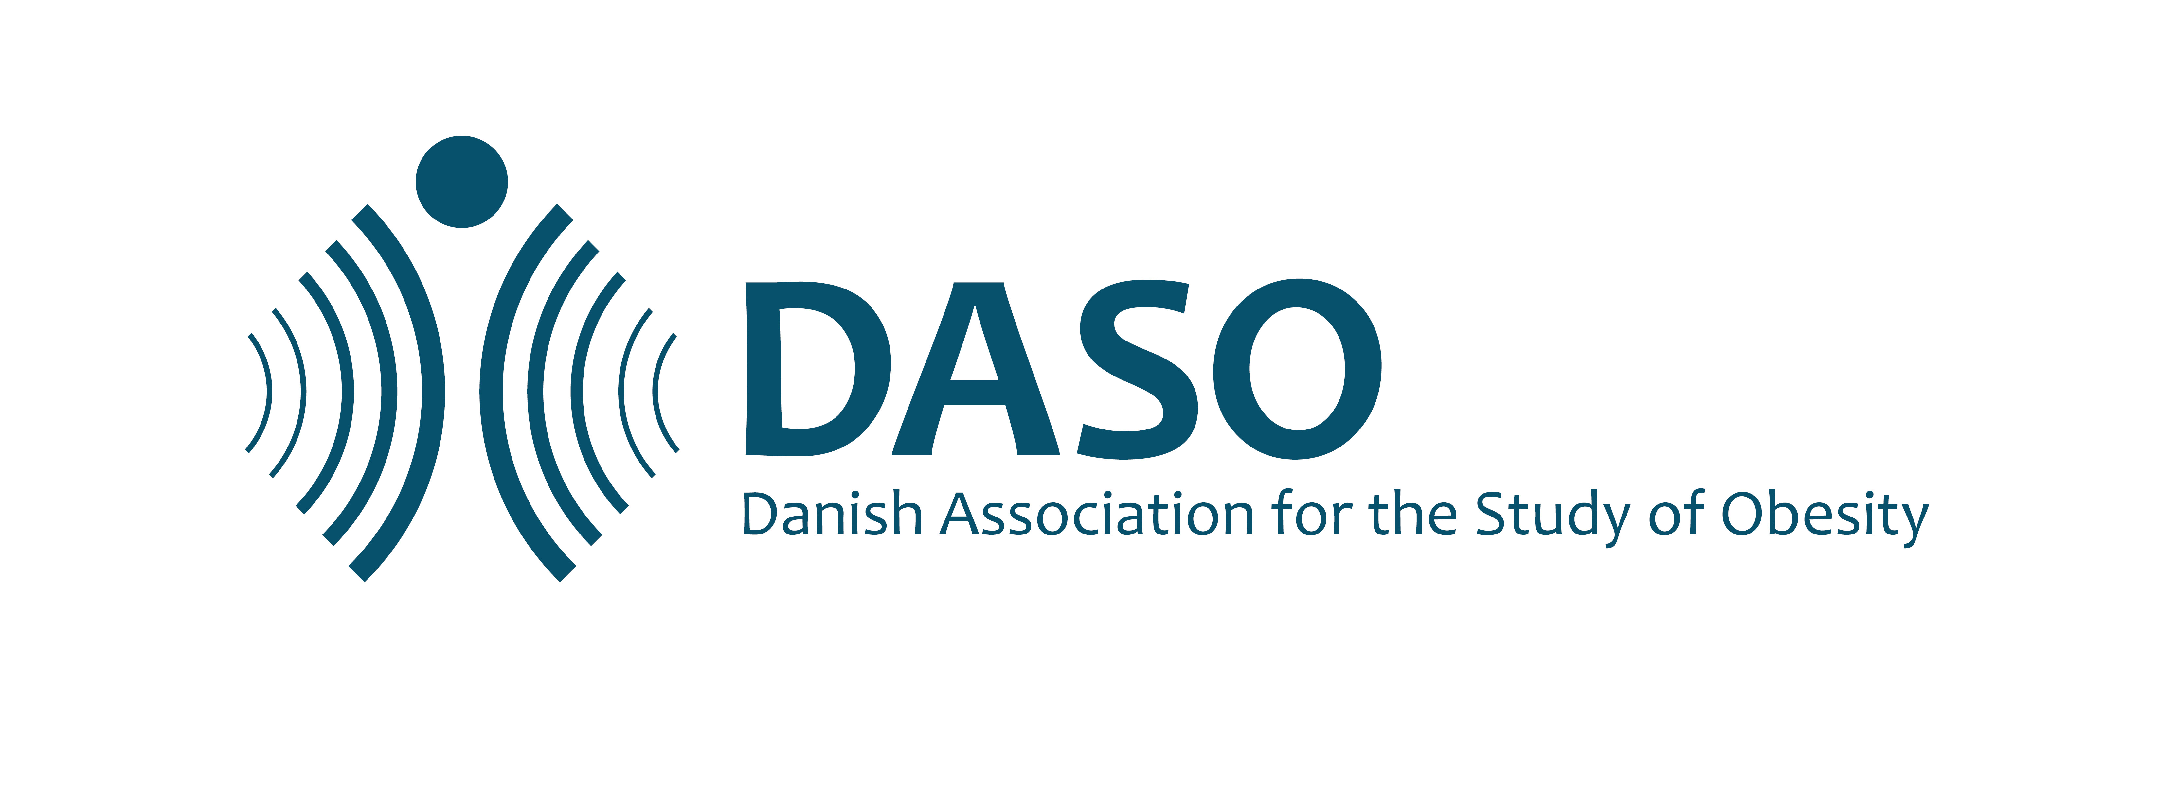

Guidelines for abstract submission

DSAF education day on obesity & Danish obesity meeting
November 2th-4th 2023

Please submit your abstract as a word file to dsaf@dsaf.dk no later than September 10th 2023. The organizing committee will select abstracts for oral or poster presentations.
Awards will be given to two early career investigators (PhD age < 10 years) to recognize excellence in their projects as well as the oral presentation. The winner receives 5000 kr. and the runner up receives 2500 kr.

All abstracts and suggestions must adhere to the EASO person first language guidelines.
It is allowed to present data which previously has been published/presented.
Be sure your abstract contains the following information and adheres to the following formatting guidelines before submission:

Abstract text: The abstract main text must contain no more than 300 words. It must be written in English, in complete sentences, and include a title, author list and affiliations and the following headings: background and aim, material and methods, results, and conclusions. All authors should be listed with name and affiliation and the presenting author in font bold. The submitted file must be labelled with the name of the presenting author. No images, figures, charts or tables should be included in the abstract.

Abstract template:
Title (Use a short and specific title) [arial 10 PT, bold]
Presenting author, other authors (Underline the presenting author’s name)
¹Affiliation: Name and address of workplace (including unit, institution/company/hospital city and country for all authors), [arial 10 PT, italics]
Abstract main text of maximum 300 words characters including spaces is written here [arial 10 PT, 1.15 spacing]. The paper size should be A4 (29.7 x 21.0 cm), with normal margins (3 cm top and bottom, 2 cm left and right). The abstract should include the following components/ subheadings:
Background and aim:
Text
Material and methods:
Text

Results (if obtained to-date):
Text
Conclusion (and perspectives):
Text

