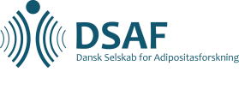

Guidelines for abstract submission

DSAF annual meeting November 9th-10th 2018

Please submit your abstract as a word file to dsaf@dsaf.dk no later than September 14^{th,} 2018. The organizing committee will select abstracts for oral presentations.
Awards will be given to two young investigators to recognize excellence in their projects as well as the oral presentation. The winner receives 5000 kr. and the runner up receives 2500 kr.

The abstract must contain no more than 250 words (text). It must be written in English, in complete sentences, and include a title and the following headings: background, objective, design, results, and conclusions. All authors should be listed with name and affiliation and the presenting author in font bold. The text in the abstract must be in Verdana, 10-pt font size, with at least 2 cm left and right margins and at least 13-pt line spacing. The submitted file must be labelled with the name of the presenting author.

