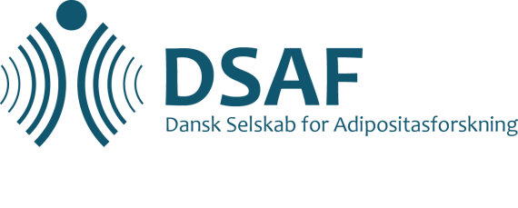

DSAF’s annual meeting 2018

Obesity: Mood, food, and the liver

Friday, November 9th
10:00-10:30: Registration and coffee with bread
Chair | Time | Speaker | Tentative title
 | 10.30-10.40 | Sigrid Bjerge Gribsholdt, MD, PhD | Welcome
 | 10.40-11.10 | Bjørn Richelsen, Professor | Lipodystrophy and leptin deficit
 | 11.10-11.40 | Liisa Lähteenmäki, Professor | Food Mood
 | 11.40-12.10 | Faidon Magkos, associate professor | Metabolic healthy obese
 | 12.10-12.40 | Inge Vinding, psykolog, klinisk diætist | Sugar addiction – what is the evidence?
 | 12.40-13:30 | Lunch
 | 13.30-13.45 | Abstract
 | 13.45-14.00 | Abstract
 | 14.14-14.30 | Abstract
 | 14.30-14:45 | Abstract
 | 14.45-15.00 | Abstract
 | 15.00-15:30 | Coffee and posterwalk
 | 15:30-16.00 | Cilius Fonvig, MD, PhD | Children and fatty liver disease
 | 16.00-16:30 | Henning Grønbæk, Professor, MD | NAFLD and patophysiology
 | 16:30-17.00 | Sasan Nazemi, PhD | Pharmacological treatment of NAFLD/NASH
 | 16:45-17.00 | Break
 | 17:00-18:00 | General assembly | All Delegates
 | 19.00- | Conference dinner with  young investigator prizes

Saturday, November 10th
Chair | Time | Speaker | Tentative title
 | 09.30-10.00 | Stanley Ulijaszek, professor | Stress and the gut
 | 10.00-10.30 | Naja Hulvej Rod, dr. med | Stressors and body weight
 | 10.30-11:00 | Christiane Duarte | Emotions and weight gain
 | 11.00-11.30 | Bjørn Richelsen og Jens Peter Kroustrup | Discussion of the Danish recommendations for pharmacological treatment of obesity
 | 11:30-11.45 | Sigrid Bjerge Gribsholt, MD, PhD | Closing remarks

